(Approx. 694 words)

Convert Books for eReaders
By Len Nasman, Editor, Bristol Village Computer Club, Ohio
January 2012 issue, BVCC newsletter
www.bvcc.org
bvclub (at) bvres.org

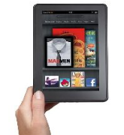
It was not exactly a Christmas present, but I now have a new Kindle Fire. We had accumulated a bunch of reward points on our PNC Bank account, and I discovered that
unused points were expiring every month. Looking through the rewards catalog, I discovered that I had enough points for a Kindle Fire. So, since the price was right, I ordered one.

It seems that if you are more than 21 years old, how to use these new-fangled things is not instantly obvious.

The Kindle Fire seems to assume that you already know how to use it, so no instruction
Manual was included. Of course there is a manual available on the Kindle, but until you know how to use the Kindle, you cannot read the manual.

Anyway, I eventually got to the point where I was ready to look for free books on the Internet and add them to the Kindle.

Free Books from Project Gutenberg
My first step was to go to the Project Gutenberg web site to look for free books.

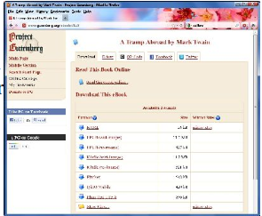
The good news about Project Gutenberg is that they now have file format options for
ereaders, including Kindle.

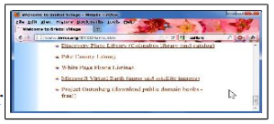
Once a book file has been downloaded to a folder in the computer’s hard drive, the question is how to copy into the ereader.

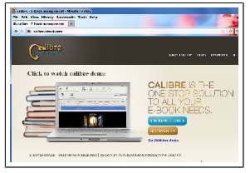
Using Calibre to Move Books
Fortunately, I discovered a free program called Calibre http://calibre-ebook.com/ that makes it almost easy to convert books and send them to different ereaders like Kindle, Nook, Android and others.

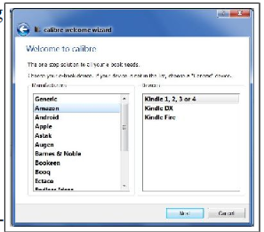
Before you start using Calibre, you need to create (using Windows Explorer) an empty folder for storing the book files you will be using with Calibre.

After your empty Calibre book folder has been created (using Windows Explorer), the Calibre installation process will ask you what eBook reader you have and what folder you will use for your Calibre book list.

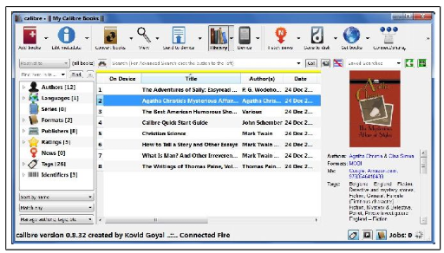
The upper left corner of the Calibre window has a tool for adding books. If you downloaded books from Project Gutenberg, you locate the files and add them to your Calibre list.

Calibre provides an option for downloading cover art and information for the books on your list. Calibre refers to this as 'metadata.'

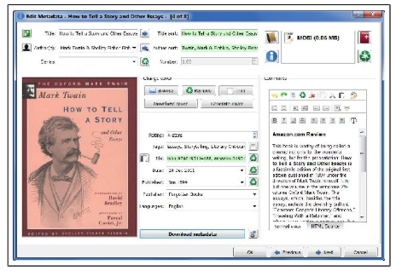
First select a book and then click on the Edit Metadata tool. There is a button in the Edit Metadata window for downloading data. When this is selected, Calibre searches the Internet for info about your book. When it finds book info in more than one location, it shows a selection list for you to pick from. You will also have the option to choose a book cover that will be displayed in your Calibre list and, in my case, eventually on the Kindle Fire list.

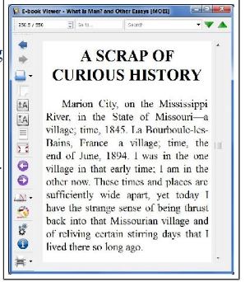
You also can read a book on your computer. Double clicking on a book in the Calibre list will open an eBook viewer right on your computer screen. (This is an option for those who travel with a laptop computer and want to use their laptop as an ereader.)

After the Calibre book list is in place, it is time to send the books to the ereader. In the case of the Kindle Fire, a USB to mini connecter computer cable was not supplied. Rather than buying this from Amazon, I got one on EBay and for a couple of dollars (including shipping).

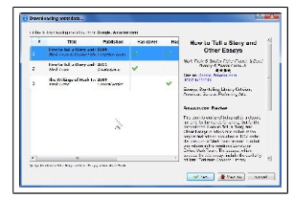
When the Kindle Fire is connected to the computer, it appears in Windows Explorer just like another disk drive. However, Windows Explorer is not used to move books to the Kindle. This is done directly from Calibre. Calibre talks directly to the ereader through the USB cable. There is a tool in Calibre that will show your ereader book list.

If you download a book from Project Gutenberg in the Kindle format, you are ready to go. If not, Calibre provides an option to convert book files to the MOBI file format that Kindle uses.

When you are ready to send books to the ereader, select the Calibre Send to Device tool. That's it. Happy reading.

